# Cherry Team

Members:

* Victor Alexiev
* Oleg Neofitov
* Ivailo Milanov
* Nencho Nenchev
* Alexander Dinov

The team has created Slickr – a gallery control which loads its images/thumbnails from Flickr or YouTube.

* Initially some local images are loaded;
* Supports keywords based image search in Flickr;
* Supports keywords based search in YouTube;
* Supports user (channel) based search in YouTube;
* The first N images/ video thumbnails are loaded in the control;
* Clicking a YouTube thumbnail displays an embedded YouTube player where the selected video file can be watched.
* Pressing the “Share to Facebook” button opens the Facebook “Post to Your Wall” dialog and the image/video is shared to the wall, where it can be played if it is a video.
* The last keyword used is saved in the local storage.

## Class Diagram



* Modules
  + controls: Slickr;
  + mediaSearch: MediaSearcher (abstract), YouTubeVideoSearcher, FlickrImageSearcher;
  + dataRetrieval: GalleryCrawler;
  + social: FacebookSharer.

## Tools, Frameworks, APIs

* Microsoft Visual Studio 2012 Ultimate;
* Microsoft Visio 2010;
* AnkhSVN – Subversion support for Visual Studio;
* jQuery v1.10.0, Prototype;
* YouTube API v2.0, YouTube API v3.0, Flickr Feed Service, Facebook Graph API;
* QUnit, Chutzpah Test Adapter for Visual Studio 2012.

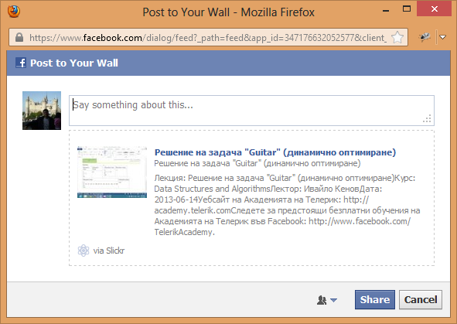

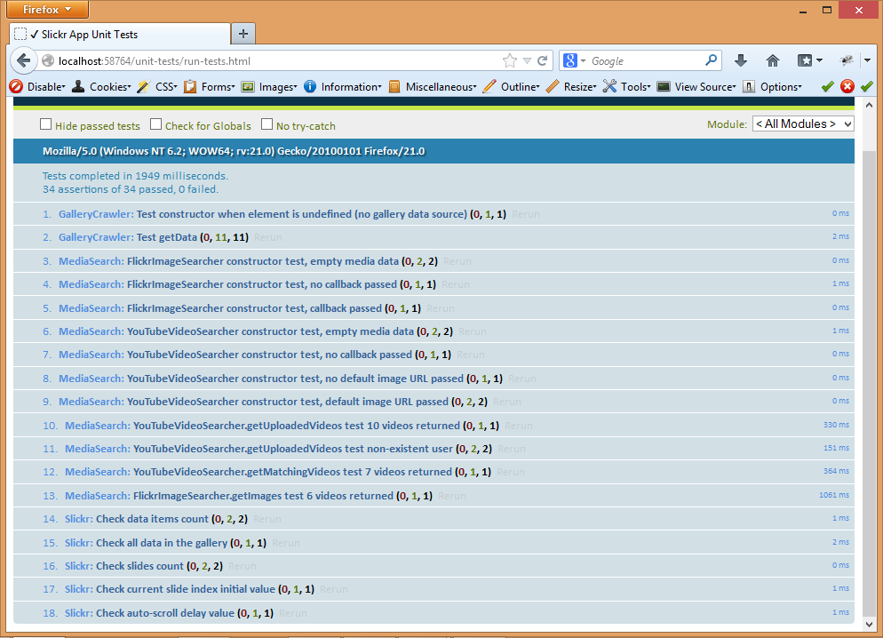

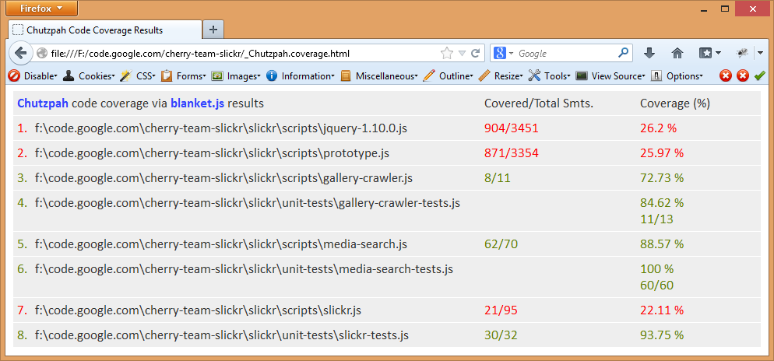

## Project URL

<https://code.google.com/p/cherry-team-slickr/>